Cheetah

Front 13”D x 8”W Rear 13”D x 10”W

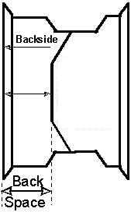
6” 2” 4” 6”

Diamond Race Race Series Wheels

Front 13”D x 8”W Rear 13”D x 10”W $75

5” 3” 4” 6”

